
San Felipe Del Rio CISD
Head Start Annual Report
2016-2017
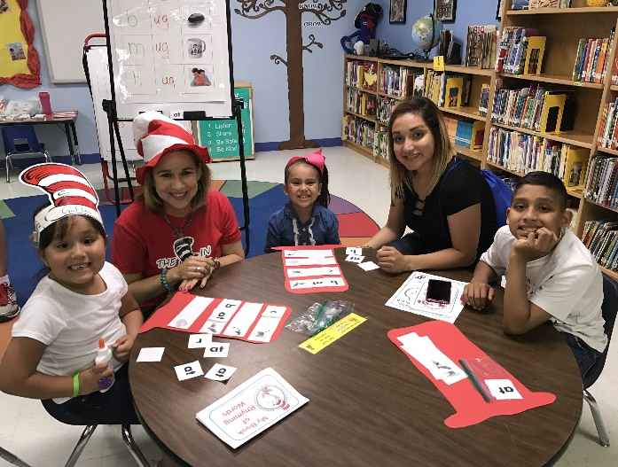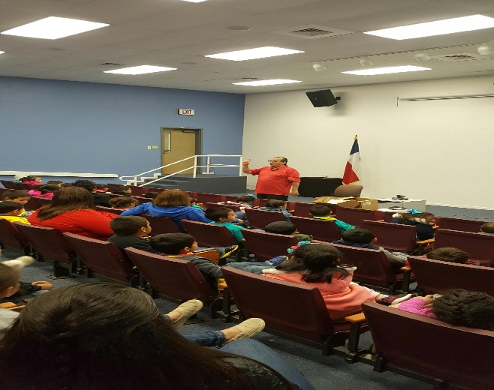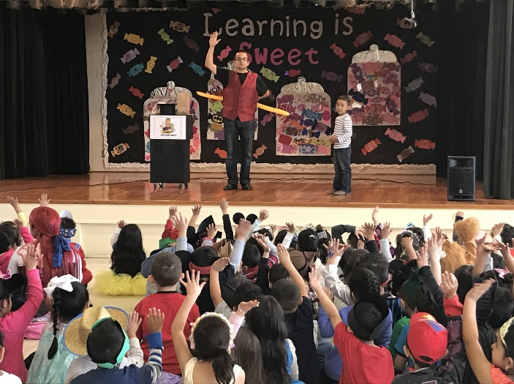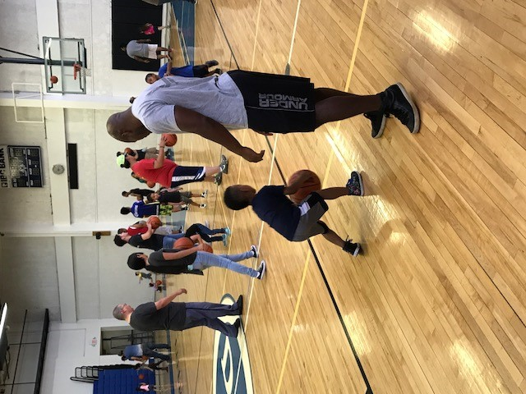
Results of the most recent review by the Administration for Children and Families - January 2016 Monitoring Review:
- CLASS Observations – The CLASS tool looks at three domains and ten dimensions of teacher child interactions and measures those observed interactions on a seven point scale. Irene Cardwell met criteria in all areas
Results of the most recent review by the Administration for Children and Families - March 2016 Monitoring Review:
- Environmental Health and Safety – Irene Cardwell all sixteen areas compliant no findings.
Results of the most recent review by the Administration for Children and Families - April 2016 Monitoring Review:

- Fiscal/ ERSEA (Eligibility, Recruitment, Selection, Enrollment, and Attendance) – Irene Cardwell - no area of noncompliance, no corrective actions.

Most recent review of SFDRCISD Head Start Financial Audit for FY 2015-2016:
There was no financial statement findings required to be reported in accordance with Government Auditing standards as noted in audit conducted by Belt Harris Pechacek, LLLP.

Public and Private Funds received
2016-2017
FUNDING SOURCE | AMOUNT$$$
US Department of Health and Human Services | $2,238,737.00
Private Funds | $0.00

2016-2017 Budget 
Head Start Categories | Amount $$
Salaries | $ 1,571,435.00
Fringe | $ 446,265.00
Supplies | $ 50,971.00
Contractual | $ 25,360.00
Equipment | $ 25,000.00
Local Travel | $ 2,000.00
Nutrition | $ 30,000.00
Parent Services | $ 5,310.00
Publications/Printing/Adver. | $ 5,000.00
T/TA including Travel | $ 32,396.00
Substitutes | $ 45,000.00
Indirect Costs | None
TOTAL Non-Federal Share 20% Match by Grantee SFRDCISD | $ 559,684.00
TOTAL Federal Assistance Award | $2,798,421.00
2017-2018 Proposed Budgets
Head Start Categories | Amount $$
Salaries | $1,568,595.00
Fringe Benefits | $ 478,788.00
Staff out-of-town travel | $ 0.00
Supplies | $ 65,038.00
Contractual | $ 23,360.00
Local Travel | $ 3,000.00
Nutrition Services | $ 30,000.00
Substitutes | $ 50,000.00
Parent Services | $ 5,390.00
Publication/Advertising/Printing | $ 4,233.00
Training/Staff Development | $ 0.00
T/TA | $ 32,396.00
Indirect Costs | None
TOTAL Non-Federal Share 20% Match by Grantee SFRDCISD | $565,200.00
TOTAL Federal Assistance Award | $2,826,000.00

Enrollment

Program | Actual # of Children Served | Actual # of Families Served | Funded Enrollment
Head Start | 390 | 378 | 346
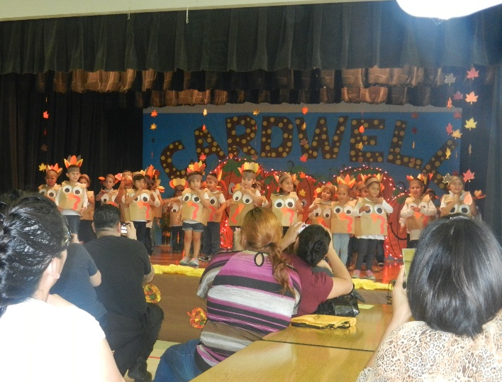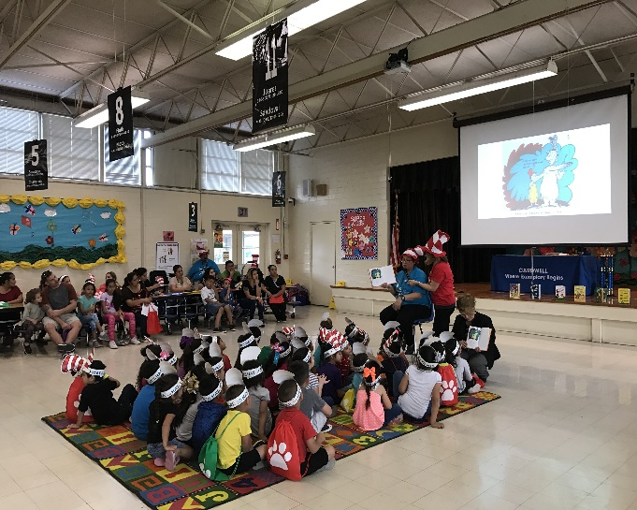
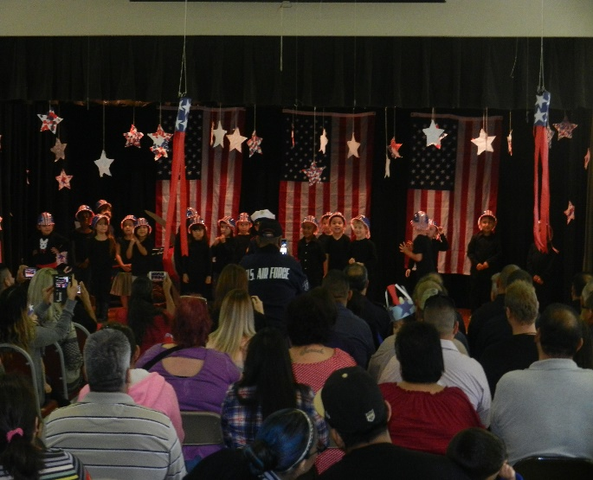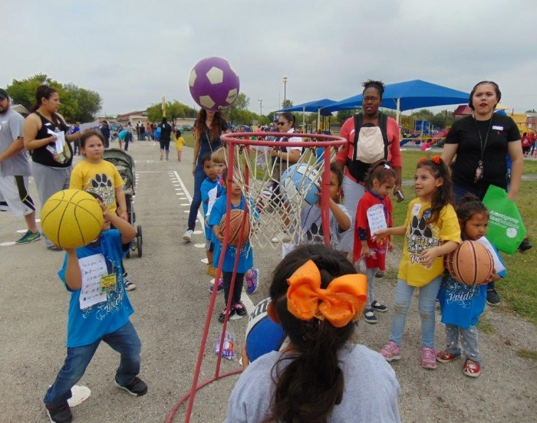
Parent Involvement
Parents participate in many ways while their children are enrolled in the program. Parents participate in two home visits and two-parent teacher conferences per school year. Other activities include:
- Working in classrooms as a volunteer
- Attending parent trainings, becoming part of the HS Policy Council
- Working with the child’s teacher and program staff to establish educational goals including School Readiness, Campus Improvement Plans, Comprehensive Needs Assessment, and campus LPAC
- Scheduling and taking their child for health and dental services
- Taking part in parent/child activities such as our family literacy programs, physical activities, music activities and Science Fair
- Activities for fathers and children that encourage participation in the educational and social expierences with the Fatherhood Initiative
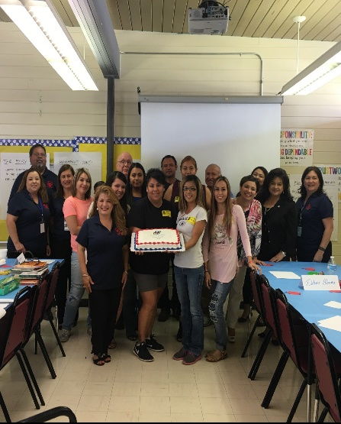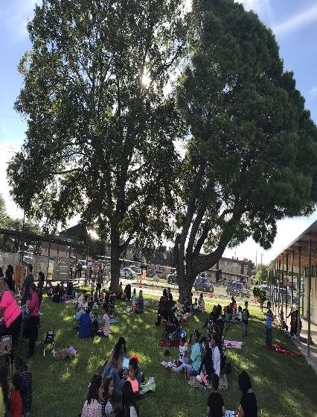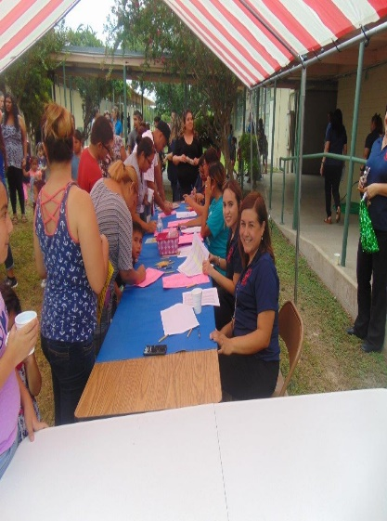
Transition 
San Felipe Del Rio CISD Head Start prepares children enrolled for the transition to Kindergarten by conducting the following activities:

- Mental Health Coordinator facilitates a homework activity to encourage parents to discuss transition with their children

- Mental Health Coordinator hosts a pep-rally with Spinoza the Bear to get children excited about going to kindergarten

- Mental Health Coordinator will arrange a bus trip in coordination with the school district to the various elementary schools in town. Students will tour their assigned kindergarten elementary campus

- Elementary principals, counselors, and teachers are invited to conduct a Kindergarten orientation for all Head Start and PK parents to help with public school to ensure a smooth transition

- Annual ARD’s will be conducted for special needs students with multiple modifications and an invitation will be given to a representative of the receiving school or the campus diagnostician

- A copy of the Individualized Education Plan will be included in the cumulative folder for all special needs students
- A copy of the Student Support Team (SST) meeting notes including classroom and home interventions will be included in the cumulative folder of all students that were referred to the SST
- Head Start assessments which include: Wood-cock Munoz/Pre-LAS, LAP-3, DECA, O.W.L. end of unit checklists, and 9 week monitoring tool are included in the cumulative folder that is sent to the child’s assigned Kindergarten Elementary campus

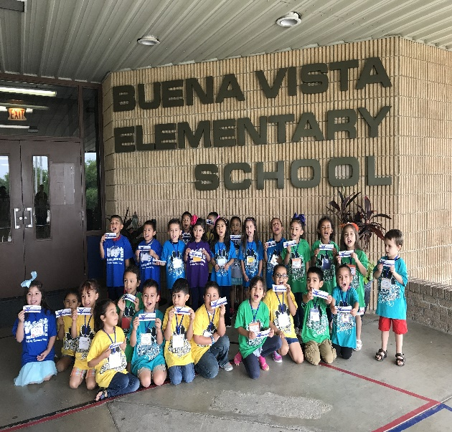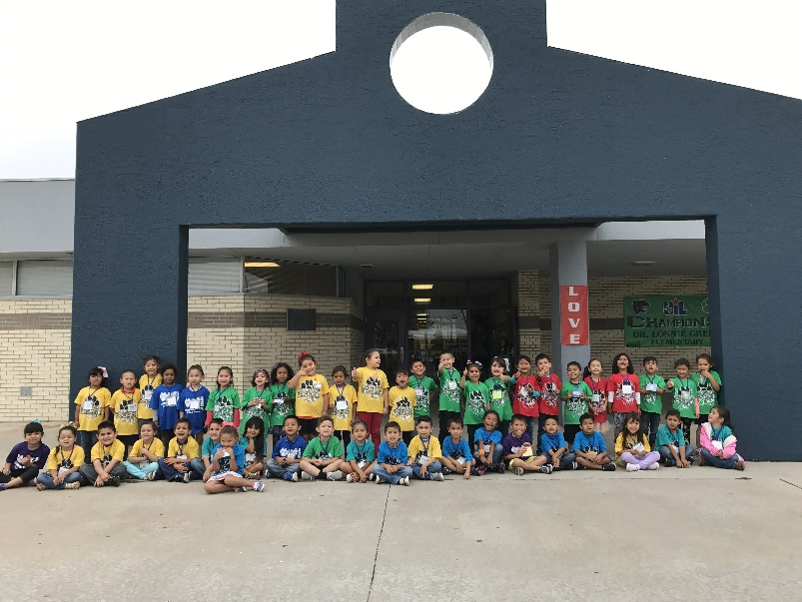

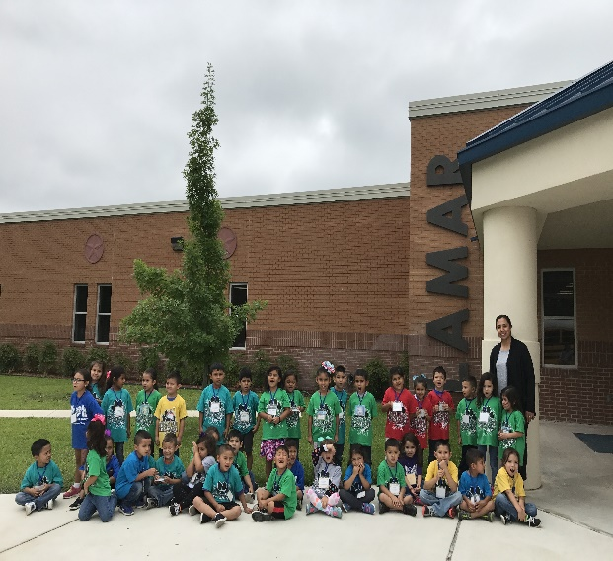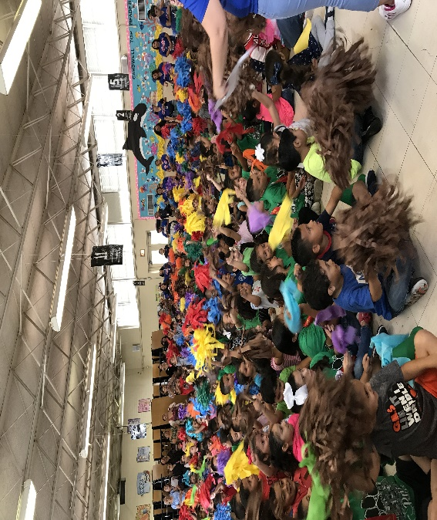
Nutrition

San Felipe Del Rio CISD Head Start serves approximately 1000 + family-
style meals daily. San Felipe Del Rio Food service provides nutritional balanced meals each day and ensuring that all children gain a full understanding of the relationship between proper eating and good health. The goal is to provide our children with nutritious, flavorful, and balanced meals.

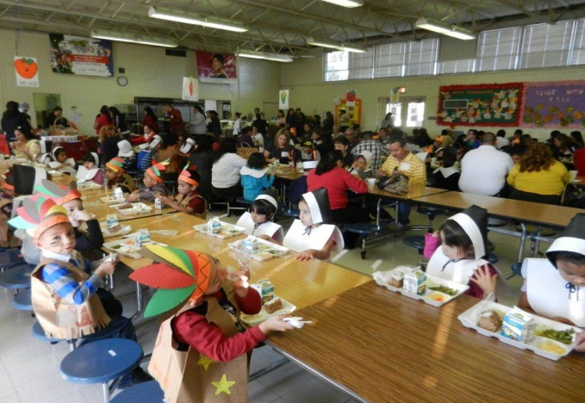
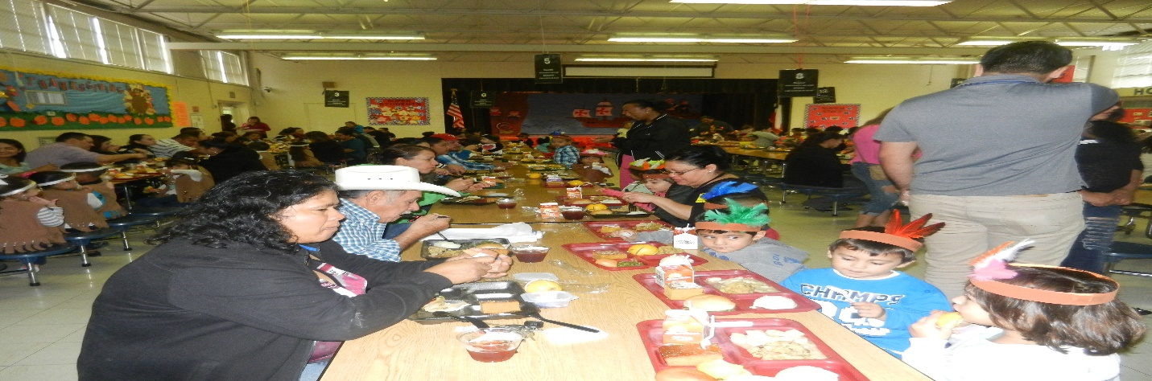
Dentals and Physicals

San Felipe Del Rio Head Start children receive health screenings on site. The health screenings help us determine how to best meet the child’s needs. The screenings include: hearing, vision, height, weight, and developmental assessment. On site student trainings for dental hygiene done yearly by HSAC member, Amigo Children’s Dental-Dr. Howard Hunt
Physical exams completed – 332 (85%)
Dental exams completed - 370 (96%)
